<https://tpchd.org/healthy-places/pools-and-spas/>

[Home](https://tpchd.org/) » [Healthy Places](https://tpchd.org/healthy-places/) » **Public Pool and Spa Safety**

**Public Pool and Spa Safety**

**Swim healthy and stay healthy!**

**Keep your kids healthy at the pool.**

* Keep kids out of water if they have diarrhea.
* Don’t let them swallow the water.
* Take bathroom breaks every hour.
* Change diapers away from the water.

Learn more about [healthy swimming](https://www.cdc.gov/healthywater/swimming/).

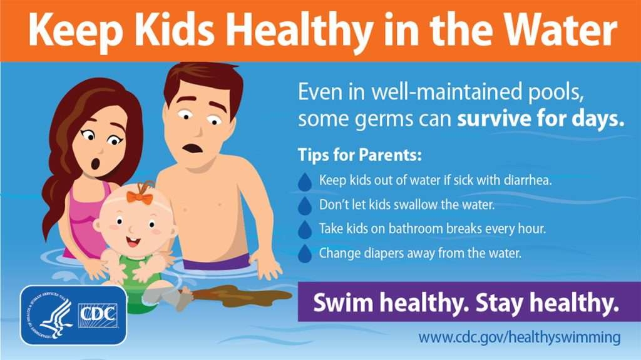

 GIF

 GIF

 GIF

**Make your pool safer with proper operation and maintenance.**

To help Pierce County pool and spa operators keep their facilities safe, we provide:

* [Training](https://tpchd.org/healthy-places/pools-and-spas/maintenance-training/).
* [Technical help](https://tpchd.org/healthy-places/pools-and-spas/information-for-operators/).
* [Useful information and resources](https://tpchd.org/healthy-places/pools-and-spas/resources/).

**Questions?**

Contact Community Safety at [communitysafety@tpchd.org](mailto:communitysafety@tpchd.org) or (253) 649-1713.

**Resources**

* [Pool and spa maintenance and safety info.](https://tpchd.org/healthy-places/pools-and-spas/resources/)
* [News Splash](https://tpchd.org/healthy-places/pools-and-spas/news-splash-newsletter/)—This is our newsletter for pool and spa operators.